Parent Self-Recommendation
Secondary School Transition 2022-23

OVERVIEW & PURPOSE
There are two reasons why we ask for you to complete this form

1. It will help you pre-think some of the important things about yourself that you may want to share in an admissions interview and/or on your school application forms.
2. It will provide us with information that will help us prepare the most effective recommendation letters possible.

This is NOT the time to be modest in your description of your child. No one will actually read these self-recommendations except for us. This information is helpful to us in writing our letters of recommendation.

Thank you for your thoughtful consideration of these questions.

Stu Work
Interim Head of School

Marisa Soulios
Principal, Grades 5-8

Debbie Martinez
Middle School Coordinator

Student's Name

Parent Completing the Form

Special Talents: describe some of the special talents your son/daughter has that you would want to be sure became known to the schools during the interview & admissions process.

Adjectives: Please list 3 adjectives that you feel best describe what is special about your son/daughter

Activities: Describe how your son/daughter was able to balance the school's academic demands with extracurricular activities, family time, downtime, rest & relaxation?

School Qualities: What qualities and/or programs do you feel are the most important priorities when selecting a Secondary School for your son/daughter? (eg. environment, religious life)

School Choice: Please list the schools you (the parent) are most interested in having your child apply to at this time, including any boarding schools you are considering.

If you are considering a faith-based school such as Loyola HS, Marymount HS, or Oaks Christian School, please describe your family's religious involvement
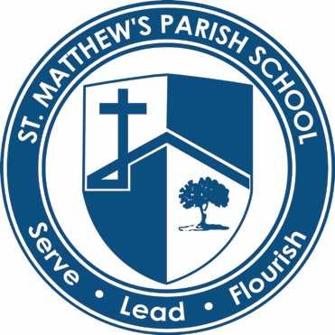

Please remind us about your volunteer involvement at St. Matthew's. The more specific you are, the more specific we can be.

